**Apache Pig on Hadoop distributed**

Downloaded and performed chown on pig home directory.

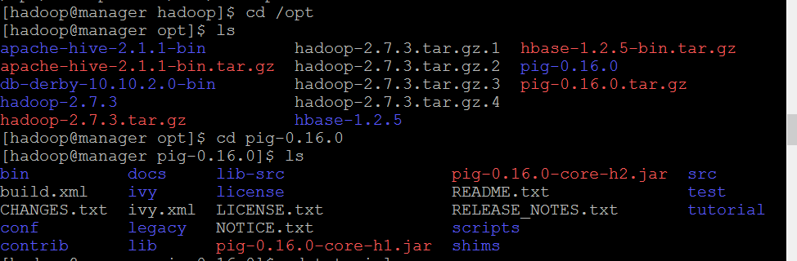

Made changes to .bashrc file to include pig home, Hadoop conf dir and pig path and classpath

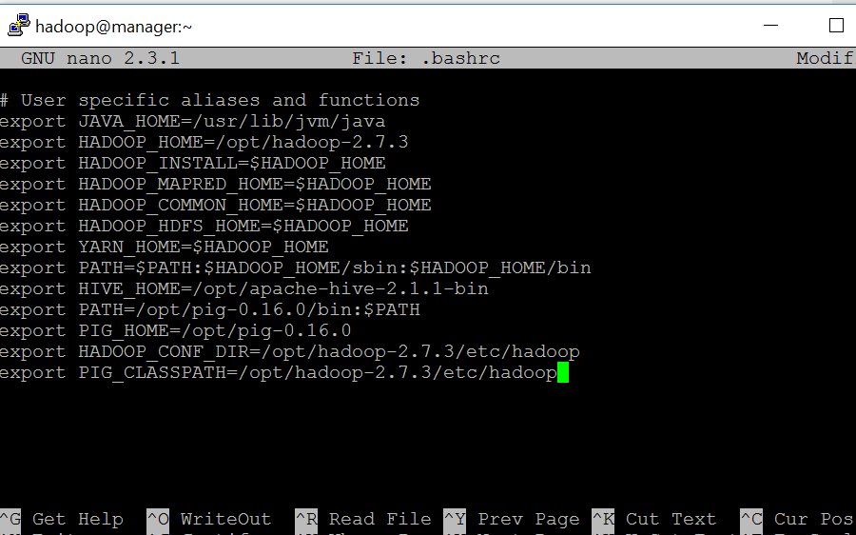

Copied tar file from tutorial directory and untarred it to create pigtmp directory

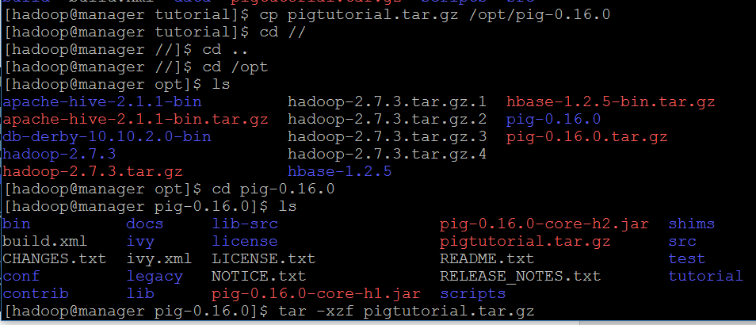

Started dfs.sh

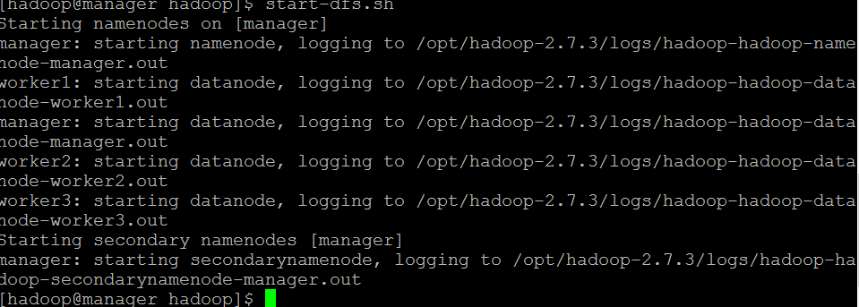

Started yarn.sh

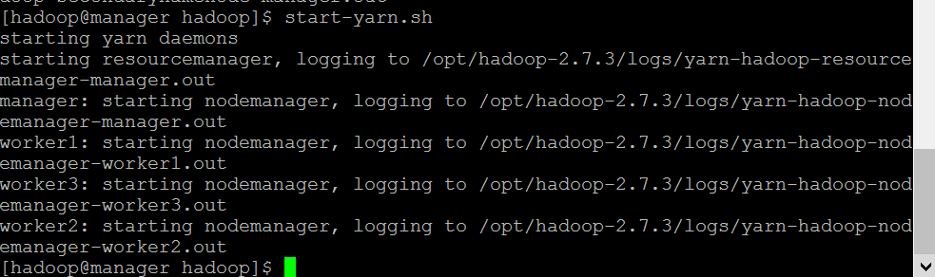

Started job history server



JPS snapshot

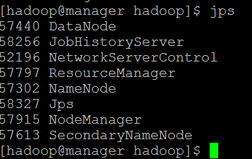

### Pig Script 1: Query Phrase Popularity

The Query Phrase Popularity script (script1-local.pig or script1-hadoop.pig) processes a search query log file from the Excite search engine and finds search phrases that occur with particular high frequency during certain times of the day.

Ran script1 file in pigtmp directory using pig command

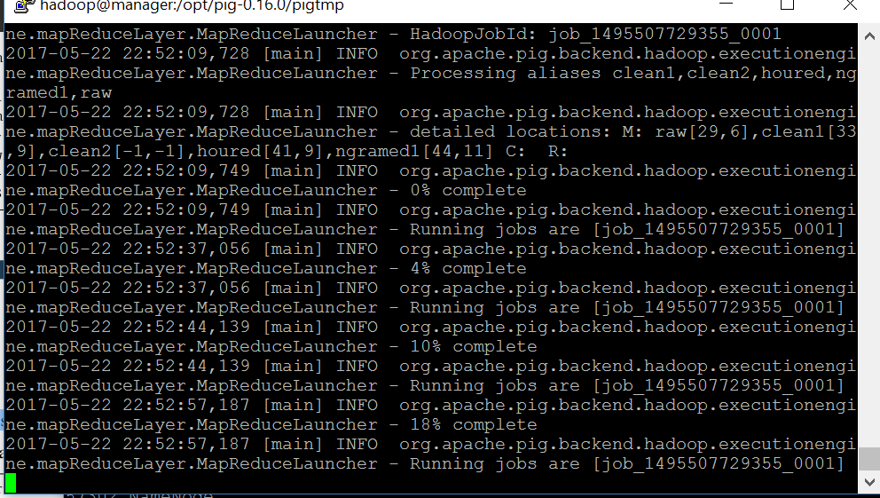

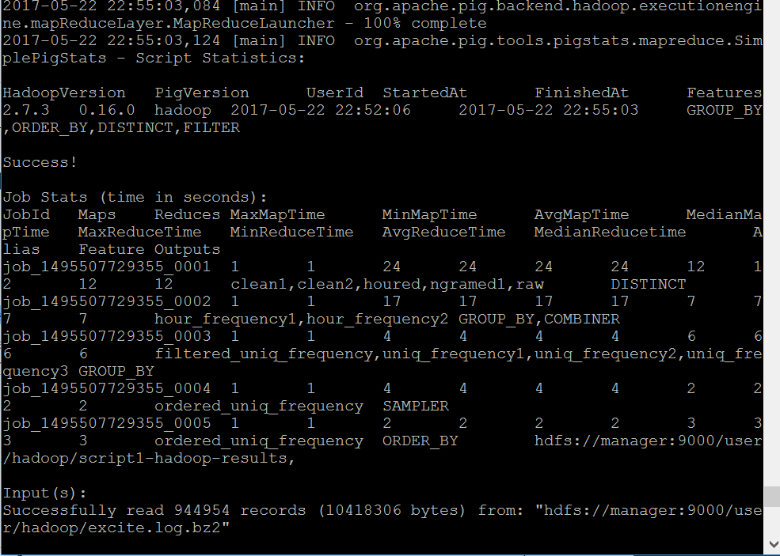

Succesfully wrote output file to /user/Hadoop/script1-hadoop-results

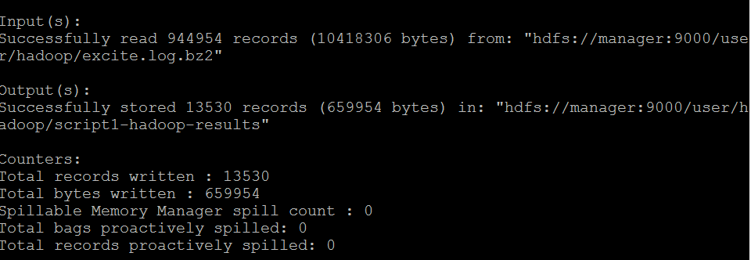

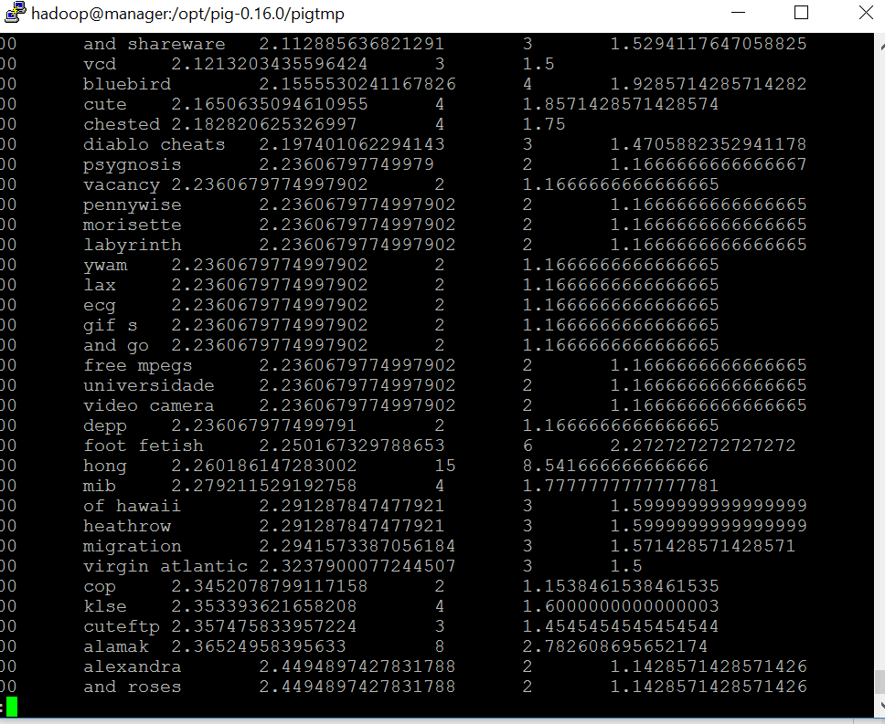

**Pig Script 2: Temporal query phrase popularity**

The Temporal Query Phrase Popularity script (script2-local.pig or script2-hadoop.pig) processes a search query log file from the Excite search engine and compares the occurrence of frequency of search phrases across two time periods separated by twelve hours.

Ran script2 in pigtmp

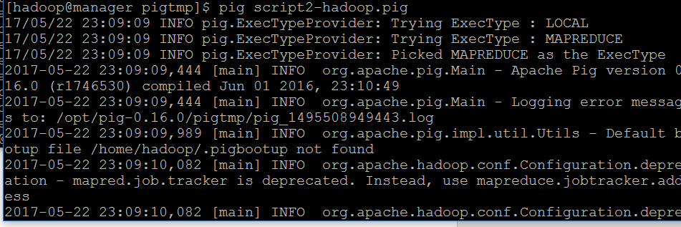

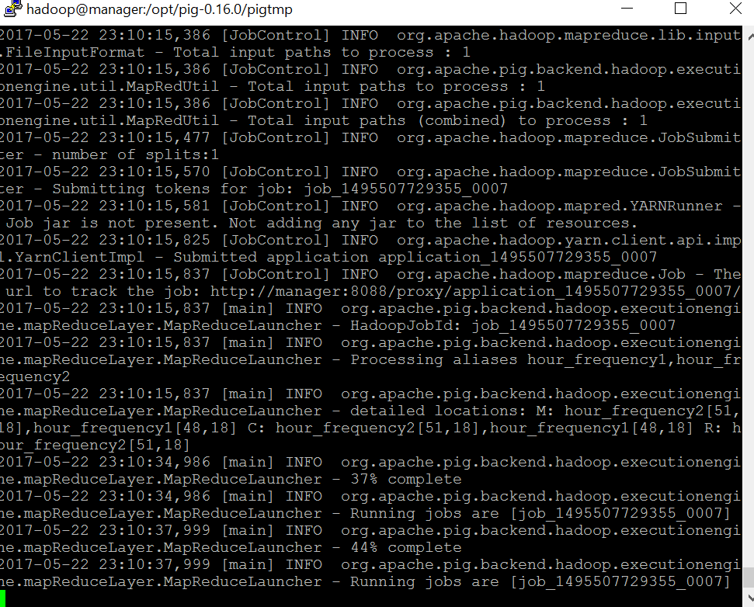

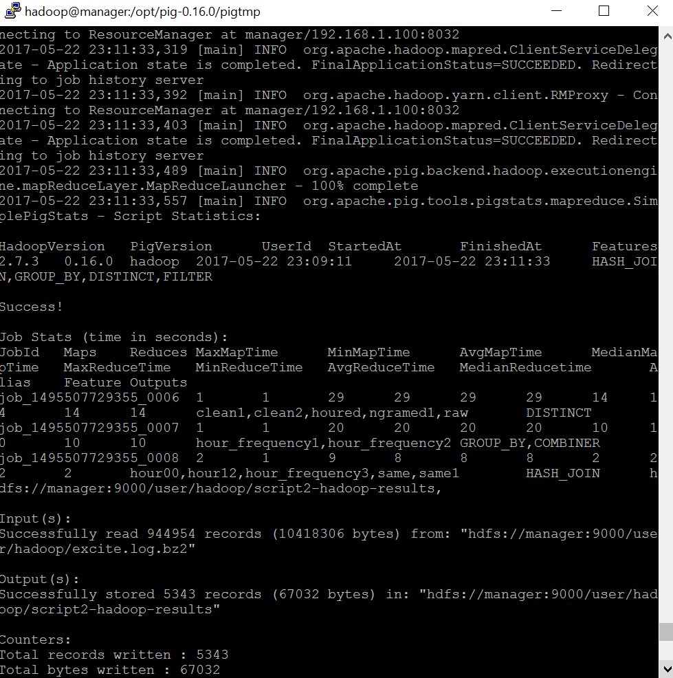

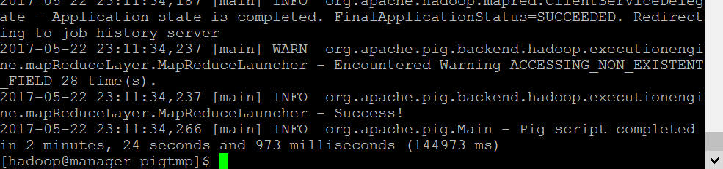

Searched Hadoop fs for script results

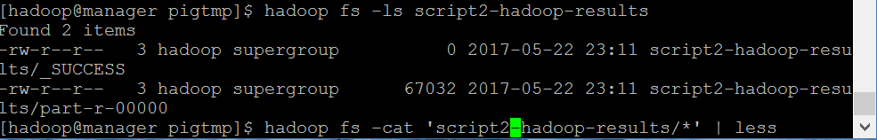

Detailed results file from pigscript2-temporal query

